AWR Dynamic Power Control Project

Overview:
AWR’s station on Guam spends more than half a million dollars on electricity every year to spread the Gospel to countries in Asia broadcasting in the HF shortwave spectrum. Shortwave broadcasters lack the data which Internet media dissemination provides, such as how many listeners, etc., but it is not traceable like the Internet either. A person in North Korea can listen quietly under the covers with a lot less risk than using a computer or phone to listen online. AWR also buys time on other broadcast facilities around the world in places like Madagascar, Tajikistan, Austria, Germany, Uzbekistan, Taiwan, and Sri Lanka. They are paying far more to these stations than the cost of power on Guam. There is at present no regular monitoring of these stations to make sure they are delivering the programs they agreed to deliver to the prospective target areas. If you are interested, the program schedule is available here. The resources available online have multiplied in the past twenty years. For a number of years there have been a number of software defined radio receiver networks online that enable one to listen to shortwave radio with a web browser. For example, the KiwiSDR network is available here. There are receivers in AWR target areas that could be used to gather data about how well AWR can be heard. This data could be used in a number of ways.
- The data could be used to make sure the programs are receivable in the target areas.
- The data could be used to help make up the program schedule each season.
- Shortwave propagation varies with the space weather. The exact location of the receiver is not as important as one might expect. For example, usually when stations in Europe are heard in Washington State, they are heard with very similar signal strengths all up and down the West Coast. Signal strengths vary as the earth rotates and sun shines on different areas of the ionosphere. At sunrise and sunset, this is very noticeable. Often the signal can vary by more than 20 dB. For a broadcaster to increase their signal by 20 dB, the power of the transmitter would need to be raised by two orders of magnitude. Sometimes the signal strength of an AWR transmission will be 20 dB louder than necessary. Other times, for example during an aurora event, the signals may not be discernible in the target area. Hopefully, this does not happen often, but it probably does occur occasionally. If the data available online giving the signal to noise ratio was sampled every few minutes, that data could be used to adjust the transmitter power in “real time” so the signal was still good, but not unnecessarily strong. This could lower the power bill for AWR. For example, if AWR was 20 dB louder than needed, the power could be cut by a factor of 100 while that condition prevailed.
- AWR uses 4x4 dipole curtain antenna arrays. Presently, they steer the beam of the antenna in the horizontal direction using switched delay lines to target different areas. It is possible that steering the beam in the vertical direction could improve AWR’s signal in the desired target area. Online receivers could be used to investigate this, and if it varies with HF propagation conditions, it could be adjusted in real time along with the power.
- The receiver network could also be used to adjust the modulation dependent carrier level (MDCL) used in the transmitters.

The first priority for my time on Guam is to make the transmitters so the power can be controlled by a computer signal. After studying the transmitter it appears the best way to do that is to replace the MDCL board.

MDCL:
AWR uses modulation dependent carrier level (MDCL) which is a way of modifying the transmitted AM signal so it uses less power. Standard amplitude modulation (AM) was designed so receivers could be built easily and inexpensively using the technology available in the early 20th century. A sinusoid at the radio frequency would be modulated (have its amplitude adjusted) as the desired audio signal, m(t), went up and down. If the radio frequency (RF) sine wave was and the audio signal to be transmitted was where |m(t)| < 1, the transmitted signal, v(t) is given by . Keeping the magnitude of the audio signal less than one makes m(t) easy to remove from v(t) and enabled very simple receivers to be constructed. Unfortunately, there is no information in the 1 term of (1 + m(t)), because it does take energy to send it. If the audio is very soft so than m(t) << 1, and the goal is to transmit the information in m(t), it is especially wasteful.

There are two different types of MDCL, Dynamic Carrier Control (DCC) and Amplitude Modulation Companding (AMC).

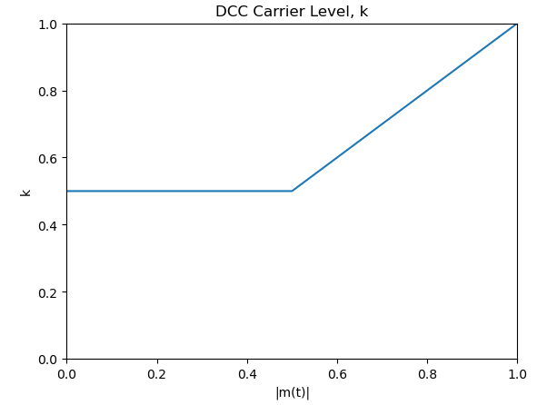
DCC reduces the 1 term in v(t), so less carrier power is transmitted when less is needed, keeping the same amount of m(t) transmitted so that the magnitude of m(t) was always less than or equal to the new constant, k, creating the “carrier”. The DCC signal would be . If k was reduced to zero when m(t) = 0, other interfering signals would likely be heard by the receiver instead of silence, because most receivers have automatic gain control (AGC) which adjusts the gain up when the signal goes down. To combat this, k is not usually reduced all the way down to zero. This leaves a flat carrier for silence, that will usually be strong enough that the small noise will be masked out and the receiver will produce silence. The graph on the previous page shows how the carrier level, k, was adjusted in the first DCC circuit the present transmitters on Guam used.

AMC takes the view that the soft or silent portions of the broadcast are more important to preserve than the loud portions. This may be more appropriate for music rather than talk. It adjusts the amplitude of v(t), instead of just the carrier, as a function of |m(t)| so .
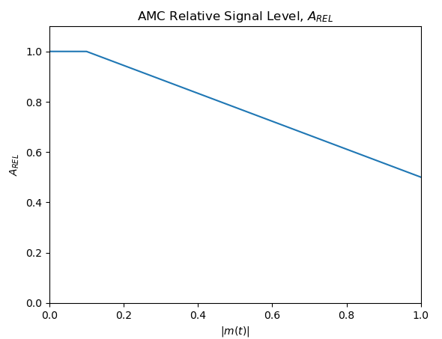
In recent years AWR has been using AMC, even though its programming is primarily talk instead of music because it reduced their power bill more than DCC would have. This is because AMC reduces the whole signal, not just the carrier, so the part of the signal carrying information is also reduced when it is louder. The actual information would have been better transferred with DCC, but the differences are only slight. Both ways reduce the power bill. Using remote receivers we may be able to tell what the best algorithm and adjustment is best. Furthermore, we could use AI to recognize the type of program being broadcast, music or speech, and perhaps change the MDCL as a function of the program type.

MDCL generally has a fast attack, slow decay, so it gradually turns the power down, and quickly turns it back up.

Transmitter Operation:
AWR Guam has five ABB SK-52 100 kW transmitters. They use the standard modulation method, where the B+ high voltage on the plate of the final amplifiers is supplied by the modulator, which produces an amplified version of the output of the MDCL output signal. By varying this voltage on the plate of the final RF amplifier, the output signal’s amplitude is set. This is called modulating the transmitter. See the diagram below.
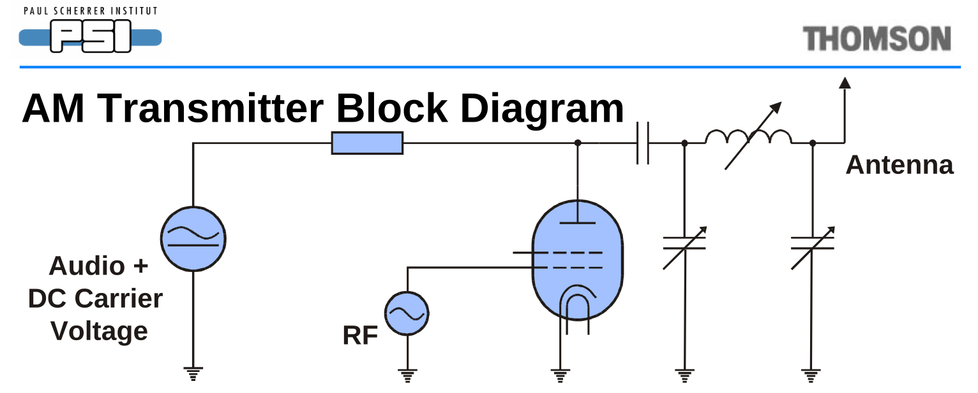
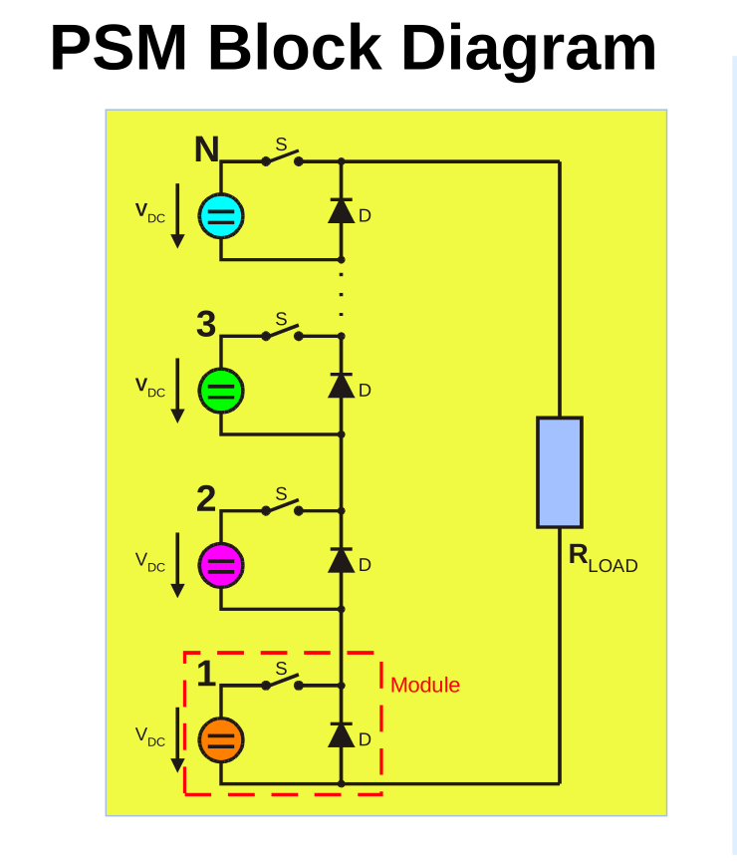
A Pulse Step Modulator (PSM) is used to create the “Audio + DC Carrier Voltage” in the diagram above. The PSM is essentially like a digital to analog converter where 26 voltage sources are switched in series by digital signals. It is like a 26 level digital to analog converter with an output of 22 kV maximum. When the AM transmitter (no MDCL) is sending silence, the PSM puts out 11 kV. At 100% modulation (|m(t)| = 1) it puts out between 0 and 22 kV as the audio goes up and down. Below is a basic diagram of a PSM. The switches are controlled digitally. The blue, green, magenta and orange circular symbols are voltage sources.
Each module is switched so that they are each on the same percentage of the time. Since there are only 26 steps with this situation, pulse width modulation is used on one of the voltage sources to remove the quantization noise. The general details can be seen in this PowerPoint presentation.

How to change the power output of the transmitter:
There is a power regulator circuit in these transmitters to keep the carrier level in standard AM constant. You can continuously adjust the power level using it, and at first we thought this was how we could turn the transmitter power up and down. After more study and experimentation, we determined that the regulator is only operational in “DSB”, what ABB calls standard AM modulation (not double sideband suppressed carrier). The regulator is disabled when MDCL is used or when transmitting single sideband (SSB). (SSB uses envelope elimination and restoration (EER), not linear amplification.) Experiments indicate the MDCL circuit will vary the power output anywhere between about 10 kW and 100 kW. The MDCL board takes 12 bits of audio plus carrier (DC) signal in, and according to the type of MDCL selected, varies the digital audio output which is also 12 bits at 100 kS/s. There is a clock that tells the MDCL board when the digital data is ready to be read, and and another tells it when it is time to send the last processed digital signal out. There are a few inputs to control whether MDCL is active too that must be monitored. The most recent MDCL board is described it an attachment. It uses two Altera FPGAs and cost AWR $90,000. We have no source code for the FPGA. We do have the schematic for the previous DCC board and it uses discrete logic ICs and EPROMs. (See attachments.) I might have been tempted to use a Raspberry Pi Pico W to do the processing, but my experience trying to read audio data from the I2S buss of an ADC and send it over WIFI or the UART would not work at more than 48 kHz at 16 bits per sample, so I decided to use a regular Raspberry Pi 5 computer running Linux. There are not enough GPIO to read and write the data in a parallel fashion, so we are using shift registers and reading it into the Pi serially. The Pi uses 3.3V logic, so we are using 74LV and 74AHCT chips for the data input and output of the Pi respectively. Other signals have a bidirectional logic level shifter. The physical dimensions of the space available dictate that the Ethernet and USB ports of the Pi will have to stick out the front of the transmitter. This should not be a big issue as there are plenty of other things sticking out like that already.

Things I am concerned about and questions I have:
- There are two clock domains, the Pi and the transmitter. I am trying to buffer them using the shift registers. Am I doing this correctly, and will there be any problems with this. I am not anywhere near as comfortable with the digital design as with analog design. What is wrong with our PCB design? We want to send it off fairly soon so we don’t lose too much time waiting for the boards.
- I plan to monitor the clocks with GPIO on the Pi and use them to create interrupts to read the digital signals.
- What is our board bring-up plan? Do we have the right test points and are there enough of them? Do we want a logic analyzer socket built into the board?
- We can do the DSP outside the ISRs. What problems will there be with this?
- The Pi running Linux is not real time. Is it fast enough?
- We want to make the maintenance needed as little as possible. The plan is to leave the same major version of Linux on the Pi. Can we get the security updates to automatically install? We can probably put a firewall on the Pi to only allow connection with remote receivers if needed, but this may need maintenance too. How do we best address this maintenance issue?
- How do we calibrate data from the receiver network so we get a good idea what the signal sounds like on a cheap SW receiver?
- AWR curtain arrays have about 20 dB gain. How do we calibrate the signals if we are using some that are not perfectly in the target area?
- If we cannot get data from the remote receivers, we can fall back to just running full power like we do now.
- How do we want to store the data we collect?
- Are there other uses we can make of this data?

